- What is react hooks?
- Hooks are special functions, that allow us to use state and other React features in functional components that were earlier available only in class components.
- Earlier, When we used to create react app using Functional component, then we didn't have access to the state management and lifecycle methods. So this was the problem with functional component.
- But after introducing React Hooks from version 16.8, we can now use state management and other react features without writing class components.
- In other words, Hooks are the functions that make functional components work like class components.
- Hooks made react functional components so easy to use.
- Developers prefer functional components over class components.

- What are the Benefits of React Hooks?
React hooks simplify the code, improves the readability, reusability and overall performance of the application.

- What is the useState Hook? Why do we need useState?
useState is a React Hook that allows functional components to create and manage state (data that changes over time).
It returns two things:
1️. The current state value
2️. A function to update that state
Example:
const [count, setCount] = useState(0);
✅ Why do we need useState?
1. To store dynamic data
Whenever a component needs to change or update some values (like input text, counter, toggle, form data), we need state.
2. Functional components had no state earlier
Before hooks, only class components could manage state.
useState gives the same power to functional components.
3. To update UI automatically
When state changes via setState, React re-renders the component automatically, updating the UI.
4. To make components interactive
Features like:
✔ counters
✔ likes/follows
✔ form inputs
✔ toggles
✔ dropdowns
✔ API response storage
all need state.
Example:
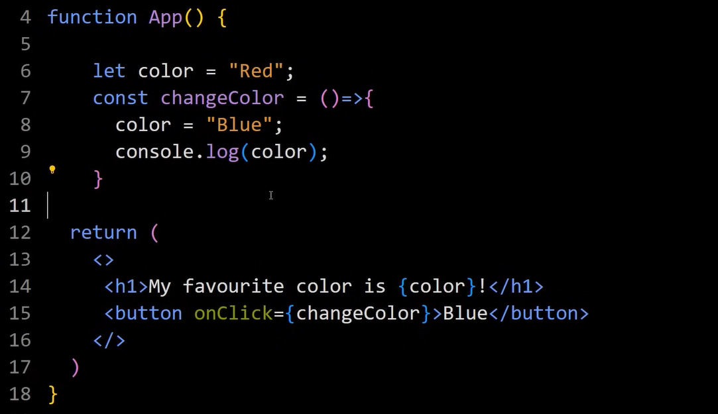

Here on clicking btn color remains red and do not change to blue.
Your color is not changing because React does NOT re-render when you update a normal variable. React re-renders the component only when state changes. Normal variables don’t update the UI. State variables do. That’s why we need useState.
The console changes because the variable value changed in JavaScript.
But React does not update the DOM until state changes.
So console shows Blue, but UI still shows Red.
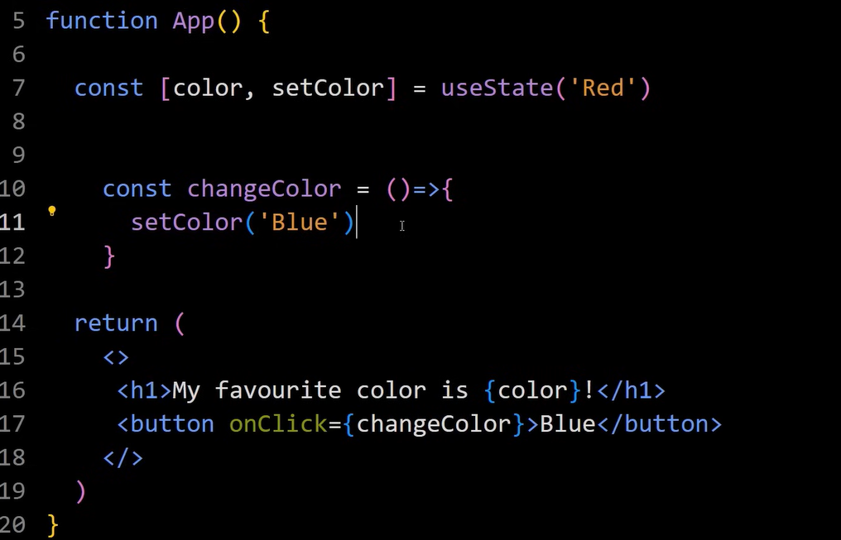
Suppose we want to update the color
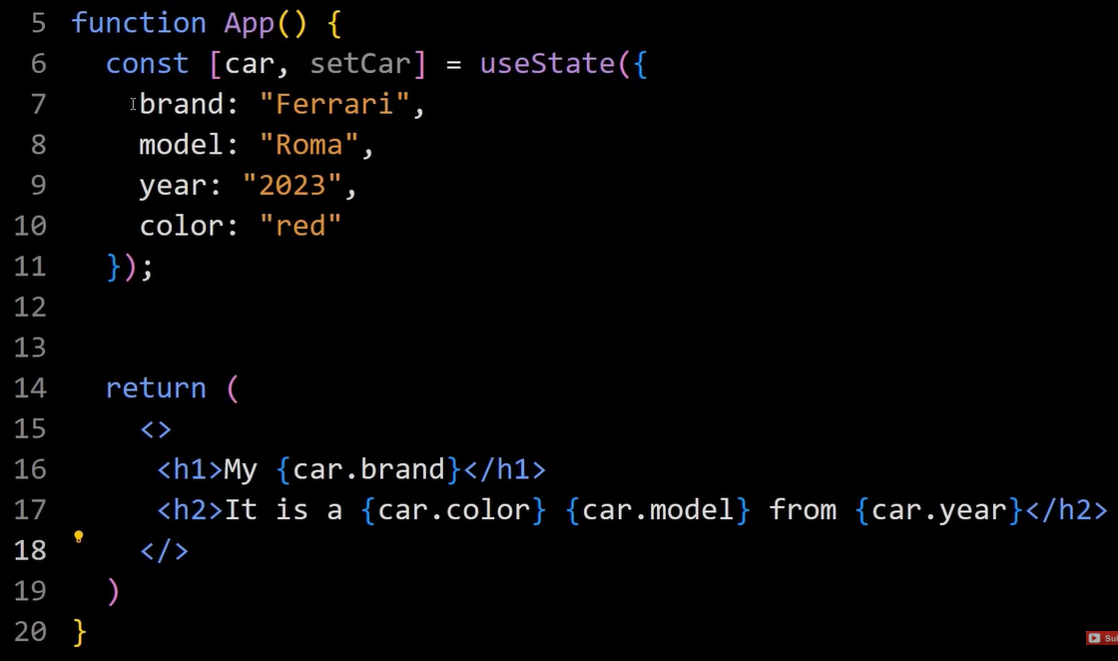
So for that we do
If we do this then whole obj data is replaced by color: “red” so we use spread operator instead
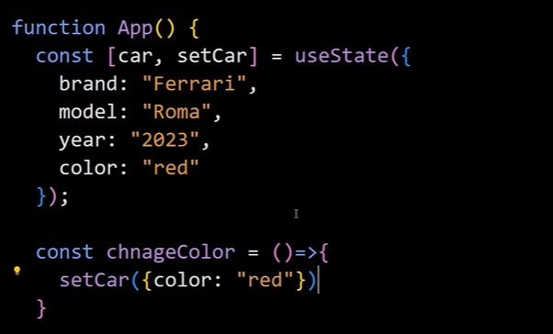
So we do like this
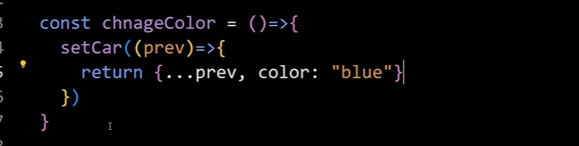

Lets see another example:
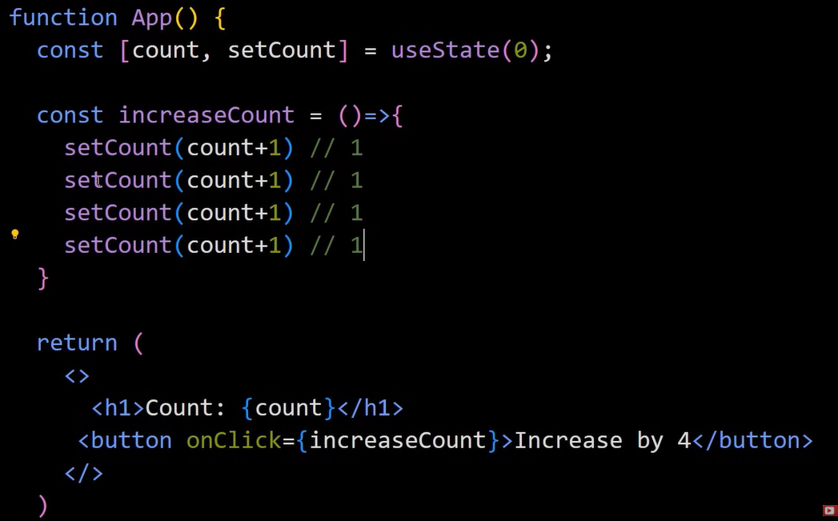

If we click on inc btn the value is increased by 1 not 4.
So to incr by 4 we have to maintain its prev state like this
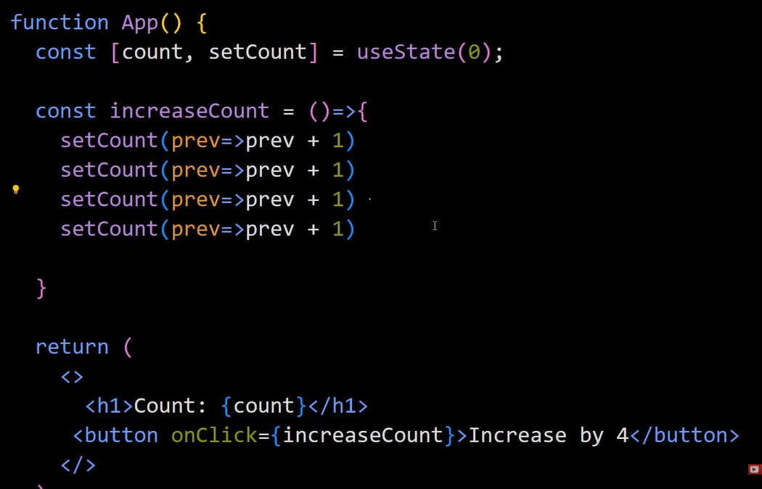

- What is useEffect Hooks?
The useEffect Hook allows you to perform side effects in your components.
Some examples of side effects are:
- Fetching data from API
- Directly updating the DOM
- Timers like SetTimeOut and Setlnterval
- replace lifecycle methods
useEffect = componentDidMount + componentDidUpdate + componentWillUnmount.
- control when code runs
Using the dependency array ([]), we can decide:
- Run only once
- Run on every render
- Run when specific values change

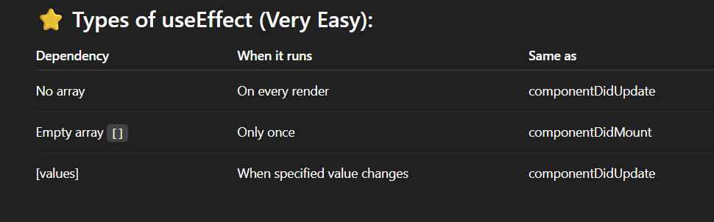
Example:
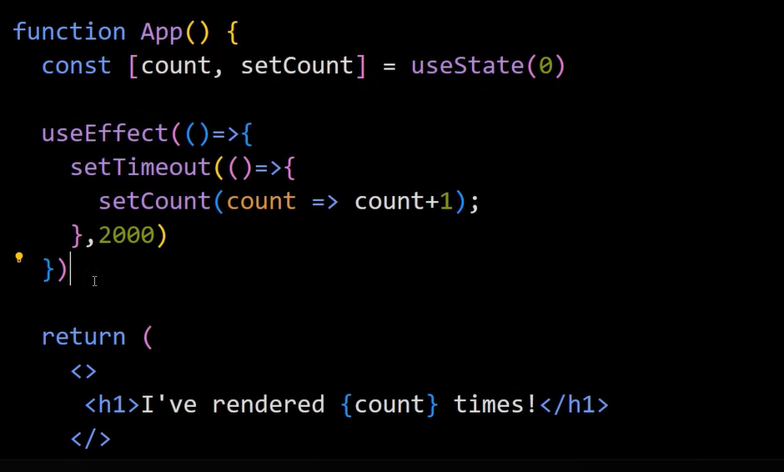
Count inc. continuously 1 2 3 4 5 …
Without a dependency array, useEffect runs after every render. Since setCount updates the state every 2 seconds, each update causes another render, which again triggers useEffect, creating a continuous loop.
When we add an empty dependency array [], the effect runs only once (on the first render), so the timer executes only one time.
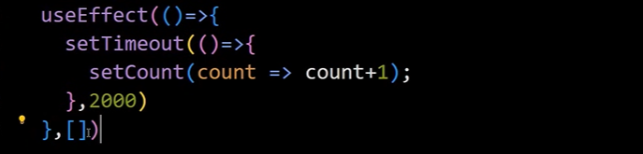

And in this case again execute infinite times 1 2 3 4 5 …
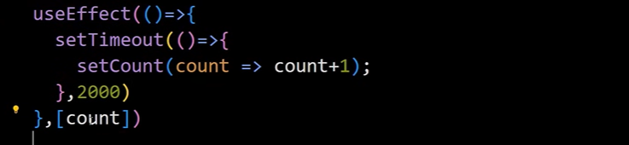

- What is useRef Hooks?
useRef is a React Hook that is used to store a mutable value that does NOT cause re-render when it changes.
It can also be used to directly access DOM elements.
The problem in this case is that count incr. for infinite time as when comp render count inc. and comp re-render again and again
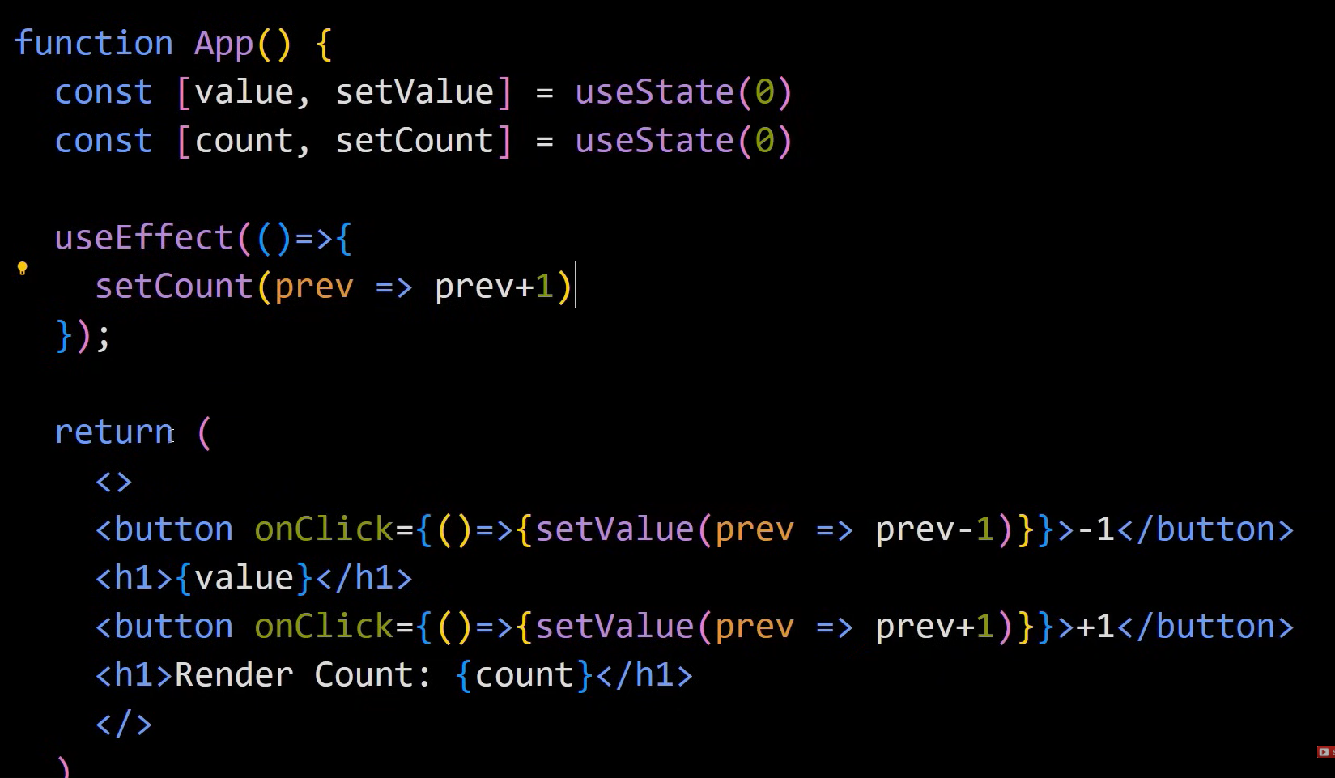


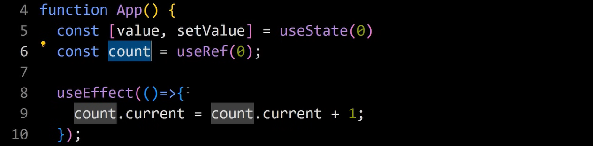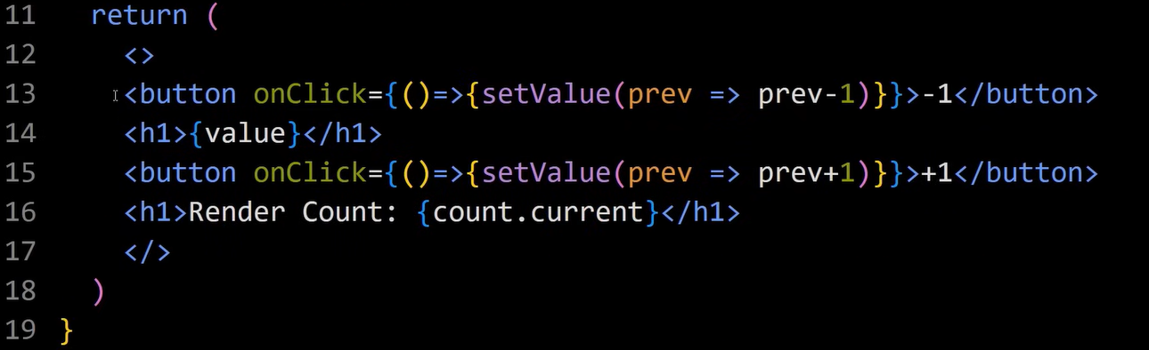
In useRef when count changes ,it does not rerender the component so here we have desired result.
When we console.log(count); we see current obj so to access that count we have to write count.current

Another Example
Accessing DOM element using useRef
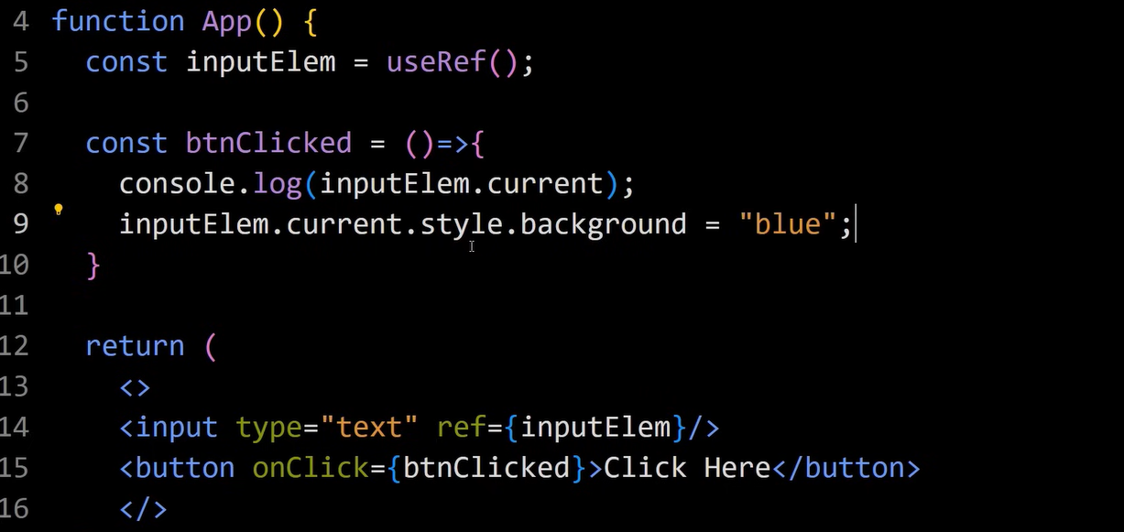
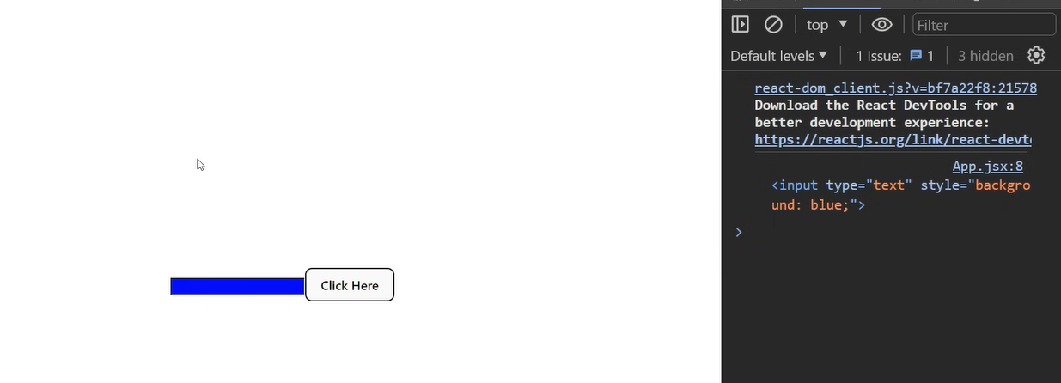
- What is useMemo Hook?
The React useMemo Hook returns a memoized value. ( it's like caching a value so that it doesn't need to be recalculated. )
The useMemo Hook only runs when one of its dependencies gets updated.
This can improve the performance of the application. There is one more hook in react to improve performance, that is useCallback hook.
⭐ Why do we need useMemo?
1. To optimize performance
If a function is slow (expensive), useMemo prevents recalculating it on every render.
2. To avoid unnecessary re-renders
It returns a cached value unless dependencies change.
3. To prevent slow components from blocking UI
Useful for:
- filtering large lists
- heavy loops
- calculations
- complex logic


Example:
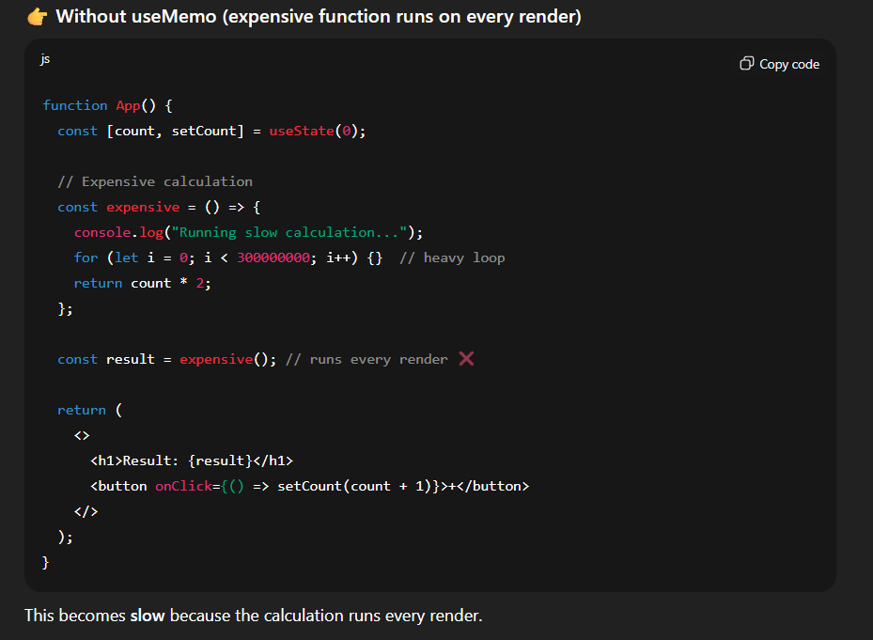
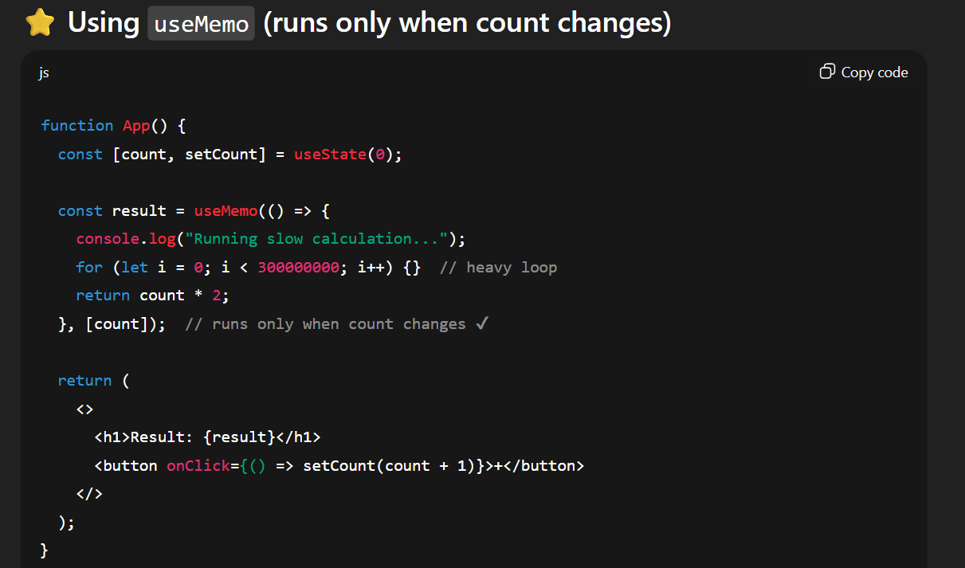
Jo immediate or just pehle calculate hh ushko store kr lega and dobara calculate nhi krega.Like yha pe jb tk [count] change nhi hoga aur page render bhi ho rha h phirbhi wo heavy fun run nhi krega so iss wjh se performance improve hoga.
- What is the useCallback Hook?
useCallback is a React Hook that memoizes (caches) a function so that it is recreated only when its dependencies change.
useCallback prevents a function from being re-created on every render.
It is Used to
- To prevent unnecessary re-renders
When we pass a function as a prop to child components, React creates a new function on every render — which can cause unnecessary re-renders.
useCallback fixes this by giving the same function reference unless dependencies change.
- To optimize performance
- To avoid expensive recalculations

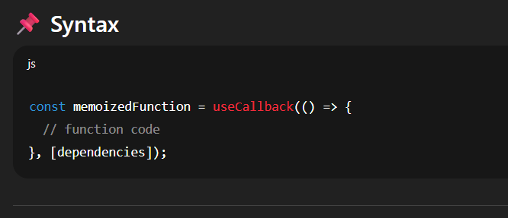

Hooks in react
- useMemo Hook

🔹 What is useMemo?
- useMemo is a React Hook used to memoize (cache) the result of a computation.
- It helps avoid expensive recalculations on every render by reusing a previously computed value if its dependencies haven’t changed.
calculateValue is a function that returns some value.
dependencies is dependency array; only when any dependency changes, the function will re-run.
If we do not use useMemo then it will cause delay as after each count component re-render.

import { useState,useMemo } from 'react'

function App() {
const [count, setCount] = useState(0);
const [input, setInput] = useState(0);

function expensiveTask(num) {
console.log("Inside Expensive Task");
for(let i=0; i<=1000000000; i++) {}
return num*2;
}

let doubleValue = useMemo(() => expensiveTask(input), [input]);
return (
<div>
<button onClick={() => setCount(count+1)}>
Increment
</button>

<div>
Count: {count}
</div>

<input
type='number'
placeholder='enter number'
value={input}
onChange={(e) => setInput(e.target.value)}

/>

<div>
Double: {doubleValue}
</div>
</div>
)
}

export default App

What is lifecycle methods in react?
Lifecycle behavior means how a component starts (Mount), updates itself, and finally ends (Unmount).
Earlier only class components had this — now useEffect() gives lifecycle to functional components.
Every React component goes through 3 stages in its life:
1️ Mounting → When component is created and shown on screen
2️ Updating → When component gets re-rendered (state/props change)
3️ Unmounting → When component is removed from the screen
These are called Lifecycle Behaviors (Lifecycle methods)
🔥 Class Component Lifecycle (Old Method)
Stage | Method | Meaning
Mounting | componentDidMount() | Runs once when component appears
Updating | componentDidUpdate() | Runs when state/props change
Unmounting | componentWillUnmount() | Runs before component disappears

